TASK 7
Dataset and Test-Scenario Plan
Drowsiness, Distraction and Phone Use, version 2

Project | Real-Time Driver Monitoring System (RTDMS)
Scope | How the face model and the phone, drink and food detector (YOLO26n) are tested
Prepared by | Youssef Medhat
Date | October 2026 (version 2, with the test results so far)
Programme | B.Sc. Graduation Project, Computer Engineering, AASTMT

Contents
1. Introduction 3
2. What We Must Prove 3
3. Datasets for Testing 3
4. Test Scenarios 4
4.1 Drowsiness 5
4.2 Distraction and head turns 5
4.3 Phone use, drinking and eating 6
4.4 Normal driving and look-alikes (false alarms) 6
5. Recording Our Own Data 7
5.1 Setup and conditions 7
5.2 Samples needed 7
5.3 How ground truth is recorded 7
5.4 Instructions for volunteers 8
5.5 Safety rules 8
5.6 Data-collection checklist 9
6. How We Measure 9
7. Results So Far 10
7.1 Face model 10
7.2 Phone and drink detector 11
8. Privacy and Ethics 12
9. Task Checklist 13
10. References 13

1. Introduction
This plan explains how we test that the system catches three unsafe behaviours, and what the tests have shown so far.
Table 1: The three behaviours
Behaviour | What it means | Detected by
Drowsiness | Eyes closed too long, slow blinks, heavy eyelids | Face model (MediaPipe [1] + EAR [2])
Distraction | Head or eyes turned away from the road | Face model (head pose + gaze)
Phone use, drinking, eating | Phone at the ear or in the hand, cup or food at the mouth | Object detector (YOLO26n) [3] + short rules

2. What We Must Prove
The targets come from the project objectives [4]:
Table 2: Targets
Requirement | Target | How we check it
Eye-closure accuracy | At least 85–90% | F1 on labelled frames
Drowsiness alert | DROWSY within 1.5 s of closed eyes | Scenario D3
Looking away | Alert after 2 s | Scenarios X1–X3
Phone use | At least 85% of phone actions caught | Scenarios P1–P4, public test sets
Phone alert time | Under 1 second | Time from phone appearing to alert
False alarms | At most 1 per 5 minutes of normal driving | Scenarios N1–N5
Whole-system delay | Under 500 ms | Raspberry Pi, all models running

3. Datasets for Testing
We use public data (ready now, repeatable) and our own recordings (our camera and car). New since version 1: SynDD, 3MDAD and DAD.
Table 3: Test datasets and status
Behaviour | Dataset | Size | What it gives us | Status
Drowsiness | CEW [5] | 2,423 face photos | Open vs closed eyes | Done
Drowsiness | MRL Eye [6] | 84,898 IR eye images | Infrared eyes, like our night camera | Done
Drowsiness | UTA-RLDD [7] | 60 people, real video | Real drowsiness over time (PERCLOS [8]) | Planned
Distraction | DG-Unicamp [9] | Gaze-zone videos | Where the driver looks | Planned
Phone, drink | SynDD [10], test drivers | 10 drivers, 20 videos | IR, mirror view, like ours | Done
Phone, drink | SynDD, 5-fold check | 59 drivers in 5 groups | How much results change between drivers | Done
Phone, drink | 3MDAD [11] | 50 drivers, 650 clips | Unseen drivers and camera | Done
Phone, drink | DAD [12] | 3 drivers, 66 min normal | Unseen real infrared camera | Done
Phone, drink | State Farm [16] | 22,424 images | Passenger-side view: wrong angle | Dropped
All | Our own recordings | 10–20 volunteers | Our camera, car and lighting | Planned

4. Test Scenarios
Each scenario is a short action the volunteer performs on a screen prompt. "Time × repeats" is how long one try lasts and how many tries each volunteer does.

4.1 Drowsiness
Table 4: Drowsiness scenarios
ID | Scenario | What the volunteer does | Time × repeats | Pass rule
D1 | Normal blinking | Looks ahead, blinks normally | 60 s × 1 | No drowsy alert
D2 | Slow blink | Closes eyes about 1 s | 1 s × 10 | Warning only
D3 | Microsleep | Closes eyes for 3 s | 3 s × 5 | DROWSY within 1.5 s
D4 | Heavy eyelids | Half-closed, slow eyes | 60 s × 1 | Warning when PERCLOS ≥ 15%
D5 | Glasses | Repeats D1–D3 with glasses | as D1–D3 | Same as without
D6 | Night (IR) | Repeats D1–D3 in the dark | as D1–D3 | Same as daytime
D7 | Sunglasses | Wears dark sunglasses | 30 s × 1 | Says "eyes not visible"

4.2 Distraction and head turns
Table 5: Distraction scenarios
ID | Scenario | What the volunteer does | Time × repeats | Pass rule
X1 | Look left / right | Turns head to the side window | 3 s × 5 each | Alert after 2 s
X2 | Look down | Looks down at the lap | 3 s × 5 | Alert after 2 s
X3 | Eyes only | Head still, eyes look down | 3 s × 5 | Alert after 2 s
X4 | Mirror check | Quick glance at a mirror | < 1 s × 10 | No alert
X5 | Turned away | Turns fully away from the camera | 3 s × 3 | "Cannot see", no false drowsy
X6 | Face covered | Covers face with a hand | 3 s × 3 | No false alarm

4.3 Phone use, drinking and eating
Table 6: Phone, drinking and eating scenarios
ID | Scenario | What the volunteer does | Time × repeats | Pass rule
P1 | Call, right ear | Holds a phone to the right ear | 15 s × 3 | Alert within 1 s
P2 | Call, left ear | Holds a phone to the left (far) ear | 15 s × 3 | Alert within 1 s
P3 | Texting at the wheel | Types with the phone at chest height | 20 s × 3 | Alert within 1 s
P4 | Texting in the lap | Types with the phone low, looking down | 20 s × 3 | Warning at 2 s, alert at 3 s
P5 | Phone in a holder | Taps a phone in a dashboard holder | 15 s × 2 | No phone alert
E1 | Drinking | Drinks from a bottle, then a cup | 15 s × 3 | Alert within 1 s
E2 | Eating | Eats a snack | 30 s × 1 | Recorded; not yet detectable

4.4 Normal driving and look-alikes (false alarms)
Table 7: Normal driving scenarios
ID | Scenario | What the volunteer does | Time × repeats | Pass rule
N1 | Normal driving | Sits as if driving, checks mirrors | 5 min × 1 | ≤ 1 false alarm
N2 | Talking, smiling, singing | Talks and laughs naturally | 2 min × 1 | No alert
N3 | Hands on the wheel | Turns the wheel, moves hands on it | 60 s × 1 | No phone alert
N4 | Hand at the face | Scratches face, hand on chin, adjusts glasses | 30 s × 1 | No alert
N5 | Passenger | A passenger talks and uses a phone | 60 s × 1 | No alert for the driver

Why N3 and N4 are new
On the unseen DAD camera the detector mistook the steering wheel in the hand for a phone, and on 3MDAD a hand at the mouth (smoking) caused false alerts. These two scenarios check that this does not happen with our camera.

5. Recording Our Own Data

5.1 Setup and conditions
Table 8: Recording setup
Item | Plan
Volunteers | 10–20 drivers (at least 10): mixed gender, age and skin tone, with and without glasses
Camera | Project camera (Pi 5 + 160° infrared camera) at the centre mirror
Video | 1296 × 972 full view, 30 frames per second
Conditions | Pass A in daylight; pass B at night (IR light on) or in a garage, with sunglasses or a hat
Props | Phone + phone holder, bottle, cup or can, a snack, wipes
Car | Parked, engine off, handbrake on; the volunteer only mimes driving
Time per person | About 25 minutes (two 6-minute guided passes + extra scenarios + setup)

5.2 Samples needed
Table 9: How many examples 10 volunteers give
Behaviour | Per volunteer | Total (10 volunteers)
Eyes closed 3 s (D3) | 5 × 2 lighting | 100
Looking away (X1–X3) | 20 | 200
Phone calls (P1, P2) | 6 + 4 in the guided passes | 100
Texting (P3, P4) | 6 + 2 in the guided passes | 80
Drinking (E1) | 3 + 4 in the guided passes | 70
Normal driving and look-alikes | about 15 minutes | about 2.5 hours

2.5 hours of normal driving lets us measure false alarms far better than the 35 minutes per group we had on SynDD.

5.3 How ground truth is recorded
- The recording tool shows one prompt at a time ("Phone to your right ear now") and saves the time of every prompt. These times are the labels, so no manual labelling is needed.
- The 0.5 s around each change is skipped (the volunteer is still reacting).
- A second team member checks 10% of the clips by eye.
- The guided pass follows a fixed 6-minute script (below).
Table 10: The 6-minute guided pass
Time (s) | Prompt | Label
0–20 | Sit normally, eyes on the road | Normal (sets the driver's baseline)
20–35 / 45–60 | Phone call, right ear / left ear | Phone at ear
70–90 | Texting, phone held low | Phone in hand
100–115 | Phone in the holder, quick tap | Look-alike
125–165 | Drink from a bottle, then a cup or can | Drinking
175–205 | Eat a snack | Eating
215–250 | Talk out loud, then sing | Look-alike
260–320 | Hand on head, scratch face, mirror glances | Look-alike
320–340 | Nod down-up ×3, turn left-right ×3 | Head-pose check

5.4 Instructions for volunteers
- Sit as you normally drive, hands on the wheel.
- Do only what the screen asks, then go back to looking ahead.
- Act naturally: hold the phone and cup the way you usually do.
- Say "stop" at any time; we stop at once and can delete your video.
- Do not start the engine or move the car.

5.5 Safety rules
- Never on a real road. Car parked, engine off, handbrake on (or a driving simulator).
- A team member stays with the volunteer the whole time.
- Eyes-closed and looking-away tests last at most 3 seconds.
- IR light is the camera's built-in low-power light only.
- Volunteers can stop at any time with no reason needed.

5.6 Data-collection checklist
Table 11: Checklist for every session
When | Check | Done
Before | Consent form signed | ☐
Before | Car parked, engine off, handbrake on | ☐
Before | Camera sees the head, both ears, hands, lap and wheel | ☐
Before | Props ready: phone, holder, bottle, cup, snack | ☐
Before | Lighting noted (day / night), glasses / sunglasses noted | ☐
During | Calibration: 10 s looking ahead, 3 s eyes closed | ☐
During | Pass A (day) and pass B (night or garage) recorded | ☐
During | Extra scenarios D1–D7, X1–X6, N1–N5 done | ☐
After | Prompt-time file saved next to each video | ☐
After | Video copied to the project computer only | ☐
After | 10% of clips checked by a second person | ☐

6. How We Measure
Table 12: Measures and success criteria
Measure | Simple meaning | Success
Recall (caught) | Of all real actions, how many raised an alert | ≥ 85% for phone calls and drowsiness
Precision | When it alerted, how often it was right | As high as possible
F1 score | One number balancing the two | ≥ 0.85
False alarms | Alerts while the driver was fine | ≤ 1 per 5 minutes (12 per hour)
Delay | Time from the action starting to the alert | Drowsy ≤ 1.5 s, distracted ≈ 2 s, phone < 1 s
Coverage | How often the face could be seen at all | ≥ 95% in normal driving

Results are reported per group (day / night, glasses, each volunteer), not only as one average. An average can hide a group the system serves badly.

7. Results So Far

7.1 Face model
Tested on the CEW test set (1,696 photos) [5] against two other approaches:
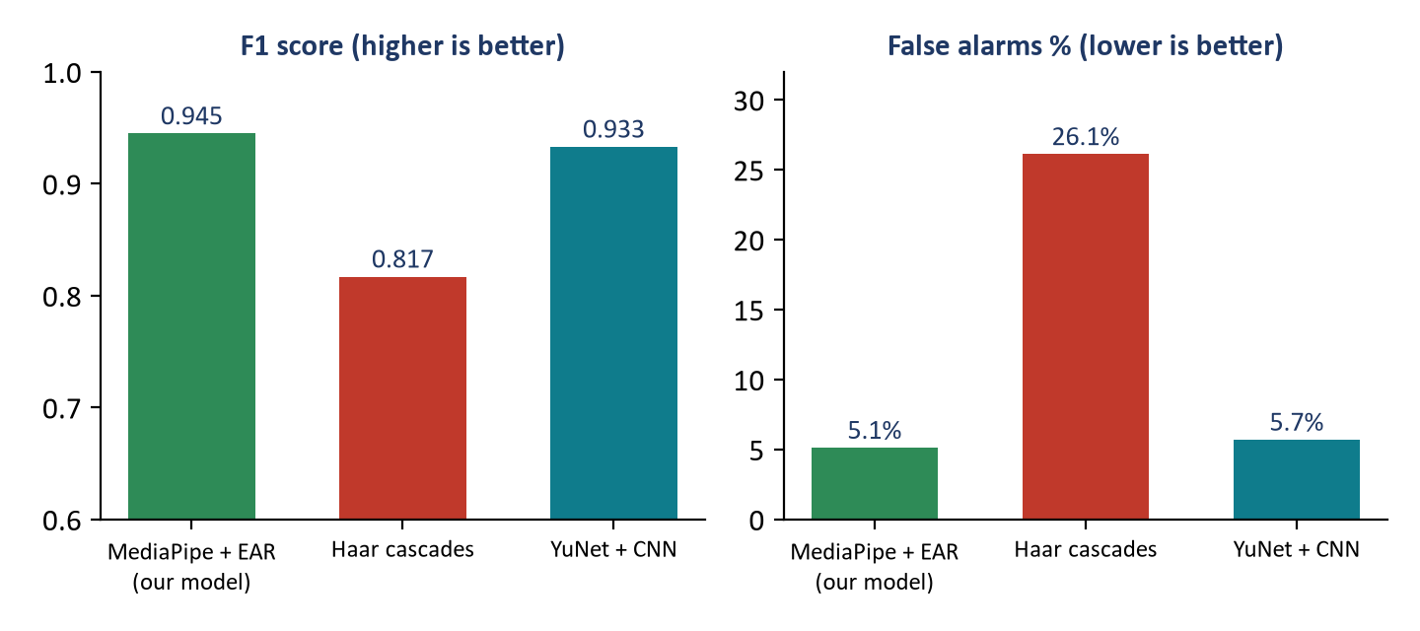
Figure 1: Face model compared with two other eye-state models (CEW test set)
Table 13: Eye-state results on CEW (laptop)
Model | F1 | Accuracy | False alarms | Speed per frame
MediaPipe + EAR (our model) | 0.945 | 94.6% | 5.1% | 5.1 ms
Haar cascades [14] | 0.817 | 80.7% | 26.1% | 9.5 ms
YuNet [15] + CNN | 0.933 | 93.5% | 5.7% | 11.8 ms

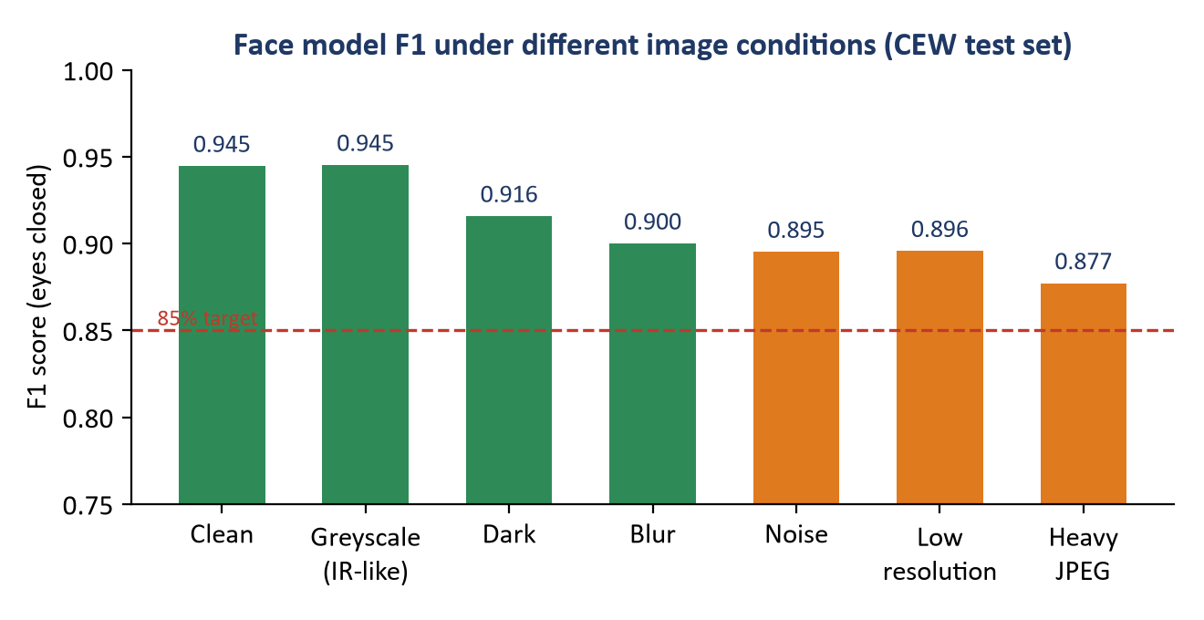
Figure 2: Face model F1 under damaged images: above 85% in every case

7.2 Phone and drink detector
Tested at alert level: did the system raise the right alert during the action, and how many false alarms happened in normal driving? Settings were chosen on validation drivers; test drivers were scored once.
Table 14: SynDD test drivers (10 drivers never seen in training)
Behaviour | Earlier detector (v2b) | Current detector (v2d)
Phone at right ear | 85% | 80%
Phone at left ear | 100% | 100%
Texting | 41% | 41.5% (46% with warnings)
Drinking | 95% | 90%
Eating | 0% | 0%
False phone alarms per hour | 1.7 | 0

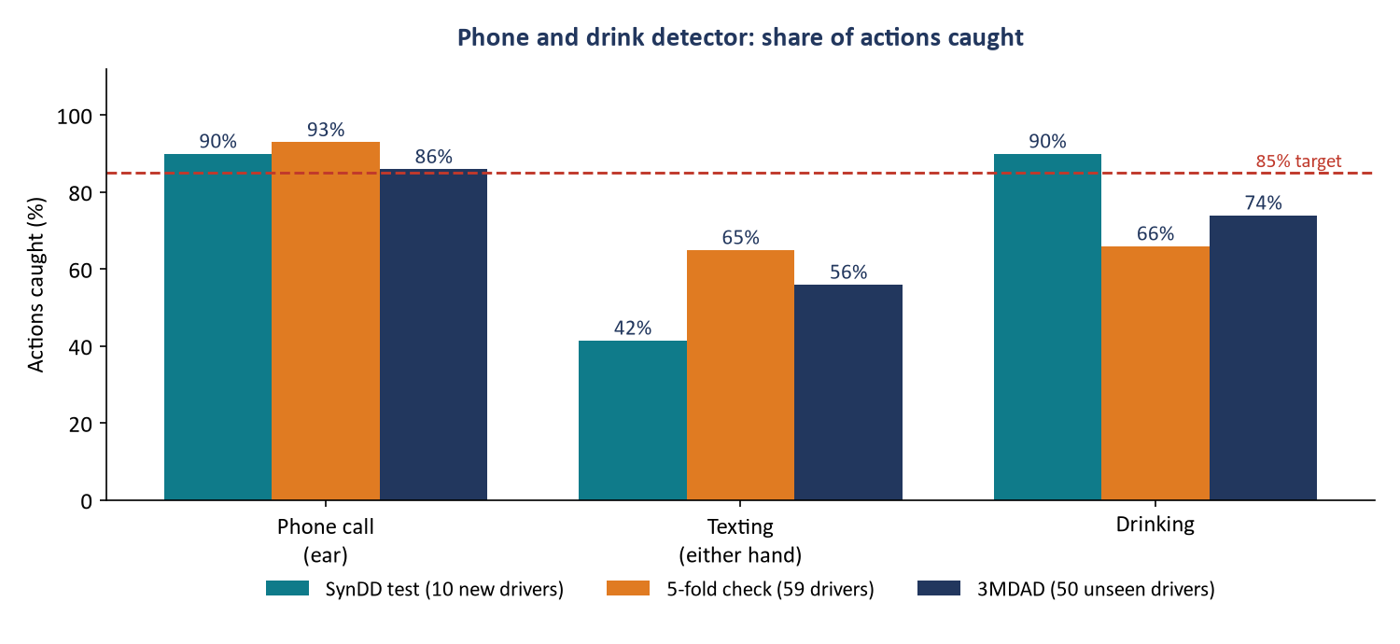
Figure 3: Share of actions caught on three test sets
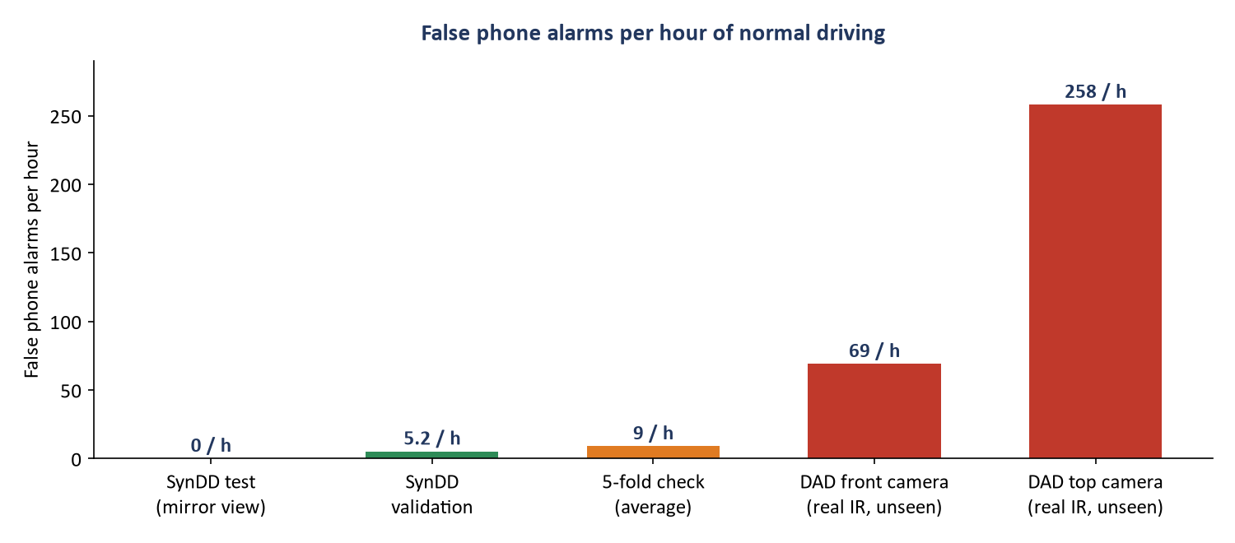
Figure 4: False phone alarms per hour of normal driving
Table 15: Results on data never used in training
Test set | Phone calls | Texting | Drinking | False phone alarms
3MDAD (50 drivers) | 80–92% | 96% right hand, 16% left (phone hidden) | 68–80% | 8% of normal clips
DAD front camera (real IR) | 4 of 5 | 5 of 6 | 2 of 2 | 69 per hour
DAD top camera (real IR) | 4 of 5 | 5 of 6 | 0 of 2 | 258 per hour

What we learned
The detector finds phones well on new drivers: 80–100% of phone calls on SynDD and 3MDAD.
False alarms depend on the camera position. On the mirror view they are low (0–9 per hour); on DAD's close-up camera the steering wheel was mistaken for a phone.
Eating is not detectable yet (0% everywhere), and texting with the phone below the camera is often missed; a head-down rule now adds a warning.
So our own recordings are the deciding test, and their normal driving will be added to training.

8. Privacy and Ethics
- Every volunteer signs a consent form and can stop at any time.
- Videos stay on the project computer only; never uploaded or put on GitHub.
- Raw videos are deleted after labelling; only labels and numbers are kept.
- No volunteer's face appears in a report without written permission.
- Public datasets are used under their licences (research use only where required).

9. Task Checklist
Table 16: Testing tasks and status
# | Task | Status
1 | Test the face model on CEW (1,696 photos) | Done
2 | Compare with two other eye models | Done
3 | Test the detector on 10 held-out SynDD drivers | Done
4 | 5-fold check on 59 SynDD drivers | Done
5 | Test on unseen data (3MDAD, DAD) | Done
6 | Guided recording tool (prompts + saved times) | Done
7 | Consent form | Planned
8 | Record 10–20 volunteers, day and night | Planned
9 | Run all scenarios on the recordings | Planned
10 | Measure speed on the Raspberry Pi with all models | Planned
11 | Write the final results report | Planned

10. References
[1] Google. MediaPipe Face Mesh V2 and BlazeFace model cards; MediaPipe Face Landmarker documentation. ai.google.dev/edge/mediapipe
[2] T. Soukupová, J. Čech. "Real-Time Eye Blink Detection using Facial Landmarks." CVWW, 2016.
[3] G. Jocher, J. Qiu. Ultralytics YOLO26. docs.ultralytics.com, 2025.
[4] RTDMS project team. Real-Time Driver Monitoring System, Project 1 Final Report. AASTMT, 2026.
[5] F. Song, X. Tan, X. Liu, S. Chen. "Eyes Closeness Detection from Still Images with Multi-scale Histograms of Principal Oriented Gradients." Pattern Recognition, 47(9):2825–2838, 2014. (CEW)
[6] R. Fusek. "Pupil Localization Using Geodesic Distance." ISVC 2018, Springer, 2018. (MRL Eye Dataset)
[7] R. Ghoddoosian, M. Galib, V. Athitsos. "A Realistic Dataset and Baseline Temporal Model for Early Drowsiness Detection." IEEE CVPR Workshops, 2019. (UTA-RLDD)
[8] D. F. Dinges, R. Grace. "PERCLOS: A Valid Psychophysiological Measure of Alertness as Assessed by Psychomotor Vigilance." US FHWA Tech Brief FHWA-MCRT-98-006, 1998.
[9] DG-Unicamp Driver Gaze Dataset, University of Campinas (as selected in the Project 1 report).
[10] M. S. Rahman et al. "Synthetic Distracted Driving (SynDD2) Dataset for Analyzing Distracted Behaviors and Various Gaze Zones of a Driver." arXiv:2204.08096, 2022. (AI City Challenge 2024 Track 3)
[11] I. Jegham, A. Ben Khalifa, I. Alouani, M. A. Mahjoub. "A Novel Public Dataset for Multimodal Multiview and Multispectral Driver Distraction Analysis: 3MDAD." Signal Processing: Image Communication, 88:115960, 2020.
[12] O. Köpüklü, J. Zheng, H. Xu, G. Rigoll. "Driver Anomaly Detection: A Dataset and Contrastive Learning Approach." IEEE WACV, 2021. (DAD)
[13] CVAT.ai Corporation. Computer Vision Annotation Tool (CVAT). github.com/cvat-ai/cvat
[14] P. Viola, M. Jones. "Rapid Object Detection using a Boosted Cascade of Simple Features." IEEE CVPR, 2001.
[15] W. Wu, H. Peng, S. Yu. "YuNet: A Tiny Millisecond-level Face Detector." Machine Intelligence Research, 20(5):656–665, 2023.
[16] State Farm. State Farm Distracted Driver Detection, Kaggle, 2016. (Used in version 1 only.)

